SPIROMETRY AND LUNG FUNCTION
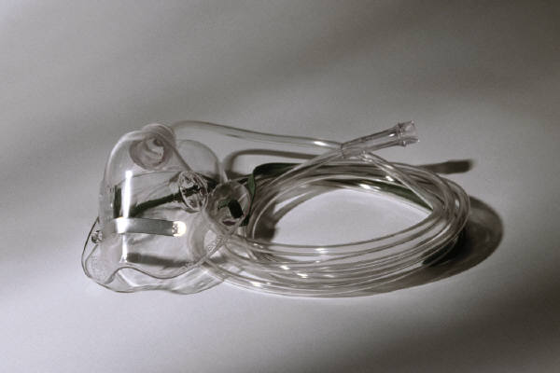
Role of Spirometry Who to refer Interpretation Protocol Patient information
The Role of Spirometry:
Spirometry is a useful tool to:
Differentiate asthma from COPD
Assess effectiveness of bronchodilators
Assess reversibility with steroids
Monitor progression of COPD
Spirometry is not necessarily diagnostic and is no substitute for a clear history. However, if performed appropriately it gives useful objective measurements of lung function.(1)
Differentiating Asthma from COPD:
History | COPD | Asthma
Smoker or ex-smoker | Nearly always | Variable
Was a chesty child | Infrequent | Often
Chronic productive cough | Common | Infrequent
Breathlessness | Gradual and progressive | Infrequent

Investigations | COPD | Asthma
FEV1 | Always reduced | Variable
Variation in PF | Minimal | Morning dip
Response to bronchodilator | Partial at best | Partial/complete
Response to steroid | Partial in 10-20% | Good response
Most confusion arises in patients with a long smoking history who also suffer from asthma.(2)
Who to Refer for Spirometry:
This is not rocket science! Patients need to be able to take 3 deep inhalations and forced expirations consistently in order for their lung function to be assessed. Patients who cannot perform a reliable peak flow will not perform a reliable lung function test either.
Interpretation of Spirometry:
Before scrutinising the spirometry results too closely, look at the percentage variability in the testing. This is expressed at the top of the result. If it shows more than 4% variation in the 3 tests, the result is difficult to interpret. If more than 10% variation has occurred, it is uninterpretable.
The two most important parameters are:
FEV1 (forced expiratory volume in one second)
FVC (forced vital capacity)
FEV1: This is a measurement of air-flow in larger airways, and is similar to Peak Flow. This can be reduced by events in the bronchus itself (i.e. bronchoconstriction, mucosal oedema, hypersecretion) or by pressure on the airways from “trapped air.”
FVC: This is total lung capacity less the residual volume. It will be reduced when the residual volume is increased due to trapped air.(1)
The percentage of observed FEV1 to predicted FEV1 is an indicator of airways obstruction. (It is not to be confused with the FEV1%, which is the percentage of forced expired air in the first second of expiration. If there is airways obstruction, the lungs empty more slowly so the FEV1% decreases).
The difference between the expected and observed FEV1 is expressed as a percentage and in COPD this defines the severity of the disease.
60-80% Mild COPD
40-60% Moderate COPD
<40% Severe COPD(3)
In asthma the FEV1 can be transiently depressed but should show significant improvement (>20%) following bronchodilation. In COPD there is usually no improvement in FEV1 following bronchodilation. In 15-20% of COPD patients there is reversibility but this is usually of the order of 10-15%. Current guidelines recommend prescribing bronchodilators if patients feel they derive benefit irrespective of the results of spirometry. Whether this is a beta-2 agonist or an antimuscarinic (or a combination of both) is best determined by trialling the medications with the patient. There is considerable inter-user variation with regard to perceived benefit.(2)
If a patient shows significant reversibility (i.e. more than 10%) a steroid trial should be performed and spirometry then repeated. Protocols suggest either 2 weeks of oral prednisolone 30mg/d, or six weeks of inhaled steroid. This assesses steroid responsiveness. If a patient has COPD and is shown to be unresponsive to steroids on spirometry they should not be prescribed steroids for their condition.(2)
If spirometry appears normal but the history suggests asthma, it is possible the test has been performed between exacerbations. In these situations a 2-4 week peak flow record is invaluable at assessing day-to-day variation in peak flow rate and “early morning dipping.”
Reference:
- Asthma. Management in Primary Care. R Pearson. Radcliffe Medical Press. 1991
- COPD Guidelines. Thorax. 1997;52(Suppl. 5) S1-32
- MeReC. National Prescribing Centre. Vol 9:10;98

Protocol For Spirometry
- Ensure patient Perform 3 sets of spirometric readings
Is not on steroids in last 10 days
Has not used long-acting beta-2 agonist or anti-muscarinic in last 24 hours
Has not used short-acting beta-2 agonist or anti-muscarinic on day of testing
Is sufficiently well to perform 3 forced inspirations and 3 forced expirations
- Nebulise patient with 2.5mg of salbutamol (unless specifically requested to do otherwise)
- Repeat 3 sets of spirometric readings 15-30 minutes after completing nebulisation.
- If FEV1 shows more than 15% improvement arrange for GP to issue prescription for prednisolone 30mg daily for 2 weeks.
- If FEV1 does not show significant reversibility refer back to GP for appropriate on-going management.
- Re-book patient for repeat spirometry in 2 weeks
- Repeat Step 1. above.
- Repeat Step 2 above.
- Refer back to GP for appropriate on-going management.

Lung Function Tests
What is Lung Function Testing?
This test measures two important numbers, FEV (air flow) and FVC (air volume). These are important indicators to help the nurse or doctor diagnose ASTHMA and CHRONIC OBSTRUCTIVE PULMONARY DISEASE (COPD), and help to monitor the course of these diseases and their response to treatment.
What to Expect.
You will be expected to blow at least 3 times into a tube connected to a machine, which will record the way your lungs function. You will be asked to inhale (breathe in) to fill up your lungs with as much air as possible, and then blow out as hard and as long as you can (at least 4 seconds each time) to get the best results.
Please follow these instructions carefully!
Please avoid smoking for at least 24 hours prior to the test
Do not consume alcohol for at least 4 hours prior to the test
Avoid vigorous exercise for at least 30 minutes before the test
Do not wear clothing that will substantially restrict full chest or abdominal expansion
Do not eat a substantial meal for in the 2 hours before the test
Do not take reliever medication (blue inhaler) for at least 4 hours before the test. (This includes atrovent).
Do not take long-acting reliever (green inhaler) for at least 24 hours before test
Do not take bronchodilator medicines in the 12 hours before the test i.e. phyllocontin, theophylline, volmax, ventolin tabs. (If in doubt check with us first).
Do not take your steroid inhaler for 10 days before the test (these are coloured brown, beige or plum!!)
If you develop a chest infection in the 2 weeks before your test, please contact us so we can rearrange your test.
If you have any queries please contact our practice nurses for advice.
This tutorial has been prepared by Dr P Harrop, Riversdale Surgery, Tuesday, 05 November 2002

